MIS 573 Homework 1

Use the “Data File Week 1_first visualization data.twbx” data set in the week 5/27 folder and answer the following questions with visualization(screenshot) and text.

1. Explore the development folder in measures. You can find several measures in the folder.
2. Create a worksheet and name it World Map_TO. Create a world map use the data set and use the color palette purple for the measure **Tourism Outbound** (5)

1. Add dimension **Years** to filter, change the filter type to single value(list) (5)
2. Create another worksheet and create an alternative visualization using heatmaps. Use **the circle** and **adjust the size** of the shapes. (See below) (10)

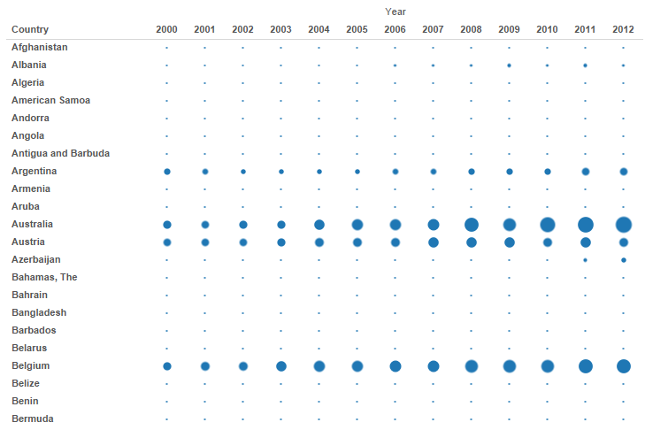

1. Save as the Tableau (.twbx) file and upload it to the assignment link. This is the first document you need to upload.

**The next section please use this file to answer the following questions.**

1. Look at the heatmap.

Name a country that demonstrates consistence in tourism outbound over the years. (5)

Name a country that demonstrates steady growth in tourism outbound over the years. (5)

1. Go to Tableau public Gallery using the following link.

<https://public.tableau.com/en-us/gallery/?tab=viz-of-the-day&type=viz-of-the-day>

There are hundreds of visualization projects across different fields including science, health, and sports etc. Please identify a project of your interest and write up a short analysis. (Do you think it’s a good visualization? Why or why not? How would you improve it? What you would have done differently? etc.) (10)

1. Name this file: YourFirstName HW1 and upload this word file to assignment link.